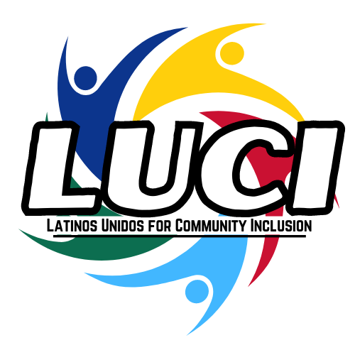

2024 Scholarship Application

Application Award

Three (3) scholarships, in the amount of $1,000 will be awarded to high school seniors (college or trade school bound) or currently enrolled college students pursuing a degree at a two or four-year accredited college/university.

Application Instructions

Please complete the attached application form to apply for the Festival Latino Scholarship and submit by June 15th, 2024. Late applications will not be accepted. Scholarship funds will be sent directly to the school that the student will be attending or is currently attending.

Eligibility

Any student attending a high school in Iowa who will be attending college or trade school after graduation is eligible to apply. Currently enrolled college students pursuing a degree at a two or four-year accredited college/university are also eligible. Students must be attending high school, trade school, or college in Linn or Johnson counties.

Requirements

- Students must be from Hispanic/Latino background
- Must be a high school graduating senior or currently enrolled college student
- Must be pursuing a degree at an accredited two-four-year institution or trade school
- Financial need must be explained
- The student must be in good standing. A GPA of 3.0 or better on a 4.0 scale is desirable
- Official transcripts (High School and College, if applicable)
- Recommendation letter from a Counselor or Academic Advisor is required
- A letter of acceptance to an accredited school shall be provided
- Three essays found in the application, half a page each (200-300 words), shall be completed
- Scholarship winners should plan to attend the Latino Festival on September 14th, 2024 (11:00am-6:00pm) to assist the Planning Committee

Applicants may submit applications via mail or electronically (preferred).
Mail application to: | Festival Latino Scholarship Committee  P.O. Box #1675  Cedar Rapids, Iowa 52406-1675
Submit application electronically to: | apino@ypniowa.org  jrok84@gmail.com  besufa@gmail.com
We look forward to receiving your application. Sincerely, Festival Latino Scholarship Committee.

1. PERSONAL INFORMATION

First Name:
Last Name:
Phone:
Email:
Address:
City:
State: Zip:

- EDUCATIONAL INFORMATION

College/Trade School/High School:
Intended Major/Program:
If other, please specify:
Cumulative GPA:
Year in School:
Graduation Date:

- EXTRACURRICULAR and VOLUNTEER ACTIVITIES

1. Activity:
Roles and Responsibilities:
2. Activity:

Roles and Responsibilities:
3. Activity:
Roles and Responsibilities:
4. Activity:
Roles and Responsibilities:
5. Activity:
Roles and Responsibilities:
6. Activity:
Roles and Responsibilities:

- Essay Questions: Please make sure your responses are no longer than half a page (150 words) for each question.

  - Explain Why You Should Be Awarded the Festival Latino Scholarship:

  - Explain Why You Chose Your Major/anticipated Major or Program:

  - Explain Your Financial Need:

Thank you for completing the application.

Prior to submitting your Scholarship application, please verify that you have included the following:

- A completed application form
- An official transcript
- A letter of recommendation from a Counselor or Academic Advisor
- Letter of acceptance to an accredited school

Signature: Date:

